ATAR Modern History

Unit 1: The French Revolution

***Practice Source Analysis***

Name: __________________________ Mark: ___ / 25 ___%

**Question 1:**

a) Compare and contrast the messages of **Sources 1** and **2**. (4 marks)

b) Evaluate the usefulness, in terms of strengths and weaknesses, of **Source 1** and **2** as representations of the social structure of the ancien regime. (5 marks)

c) Explain the historical context of **Source 3**. (4 marks)

d) Identify and account for the authors’ perspectives in **Source 3** and **4** regarding the Three Estates.

(6 marks)

e) Evaluate the extent to which the **four sources** give an accurate insight into the significance of the equality experienced between the social classes in the ancien regime. (6 marks)

**Source 1**

*(Political cartoon from 1789. Author/publication unknown.)*

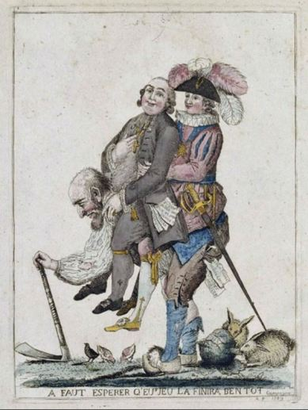

**Source 2**

*(Encyclopaedia Britannica (2017) France 1715-89. Available online at* [*https://www.britannica.com/place/France/France-1715-89#ref465109*](https://www.britannica.com/place/France/France-1715-89#ref465109)*.)*

*France itself can be conceived of as an aggregate of differentiated groups or communities (villages, parishes, or guilds), all of them theoretically comparable but all of them different. In many respects the kingdom was an assembly of varying provinces, a number of them endowed with vestigial representative institutions. In some important ways France was not truly a unit of government. Unlike England, for example, France was not a single customs union; more tariffs had to be paid by shippers on brandy floated down the Garonne to Bordeaux than on wine shipped from France to Britain.*

**Source 3**

*(*An idealised view of rural France of the Ancien Regime. Date unknown)

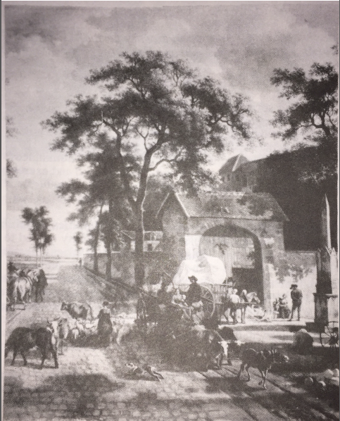

**Source 4**

*(*Adcock, M. (2004) *Analysing the French Revolution. Cambridge Publishing*)

*Note: This diagram shows the different groups in French society in 1789 and their relative numerical importance. Figures are approximate based on historical evidence.*

